Rexa Chatbot Application - User Guide

What is this Application?
The Rexa Chatbot is a conversational AI application that allows you to chat with different AI models through a WhatsApp-style interface. It's built using Streamlit (for the web interface) and integrates with Ollama (a local AI model runner) to provide intelligent responses.

Key Features

Chat Interface
- WhatsApp-like Design: The application mimics WhatsApp's familiar green and white color scheme with message bubbles
- Real-time Conversation: Messages appear instantly with your messages on the right (green) and AI responses on the left (white)
- Message History: All your conversations are saved during your session

AI Model Selection
- Multiple Models Available: Choose from 7 different AI models including Llama3, Gemma, Phi, and Neural-Chat
- Easy Switching: Change models anytime from the sidebar - conversation resets when you switch
- Model Persistence: Your selected model stays active throughout your session

Customization Options
- Temperature Control: Adjust creativity level from 0.0 (very focused) to 1.0 (very creative)
- System Prompt: Customize how the AI behaves by setting instructions (default: helpful assistant for Rexa)
- Personal Touch: The AI knows it's talking to "Rexa" and can personalize responses

Conversation Management
- Clear Conversation: Reset chat history with one click
- Stop Generation: Interrupt AI responses if they're too long
- Session Memory: Chat history persists until you refresh or clear

How to Use

Getting Started
- Open the application in your web browser
2.You'll see a chat interface with "Rexa Chatbot" at the top
3.The sidebar on the left contains all your controls

Having a Conversation
- Type your message in the input box at the bottom
- Press Enter or click send
- Wait for the AI to respond (you'll see a typing indicator)
- Continue the conversation naturally

Customizing Your Experience
- Change AI Model: Use the dropdown in the sidebar to select different models
- Adjust Creativity: Move the temperature slider - higher = more creative responses
- Set Behavior: Modify the system prompt to change how the AI acts
- Reset if Needed: Use "Clear Conversation" to start fresh

Technical Requirements
- Ollama Installation: Must have Ollama installed and running on your computer
- AI Models: Selected models must be downloaded in Ollama first
- Web Browser: Works in any modern web browser
- Internet: Not required once models are downloaded locally

Tips for Best Experience
- Start Simple: Begin with basic questions to test the AI
- Be Specific: Clear, detailed questions get better responses
- Experiment: Try different models to find your favorite
- Use System Prompts: Customize the AI's personality for your needs
- Temperature Settings: Use low (0.1-0.3) for factual answers, high (0.7-1.0) for creative tasks

Benefits
- Privacy: All processing happens locally on your computer
- Cost-Effective: No API fees or subscription costs
- Customizable: Full control over AI behavior and responses
- User-Friendly: Familiar WhatsApp-style interface
- Fast Response: Direct local processing without internet delays

CONCLUSION:
This application provides a professional yet user-friendly way to interact with powerful AI models locally, giving you both convenience and control over your AI conversations.
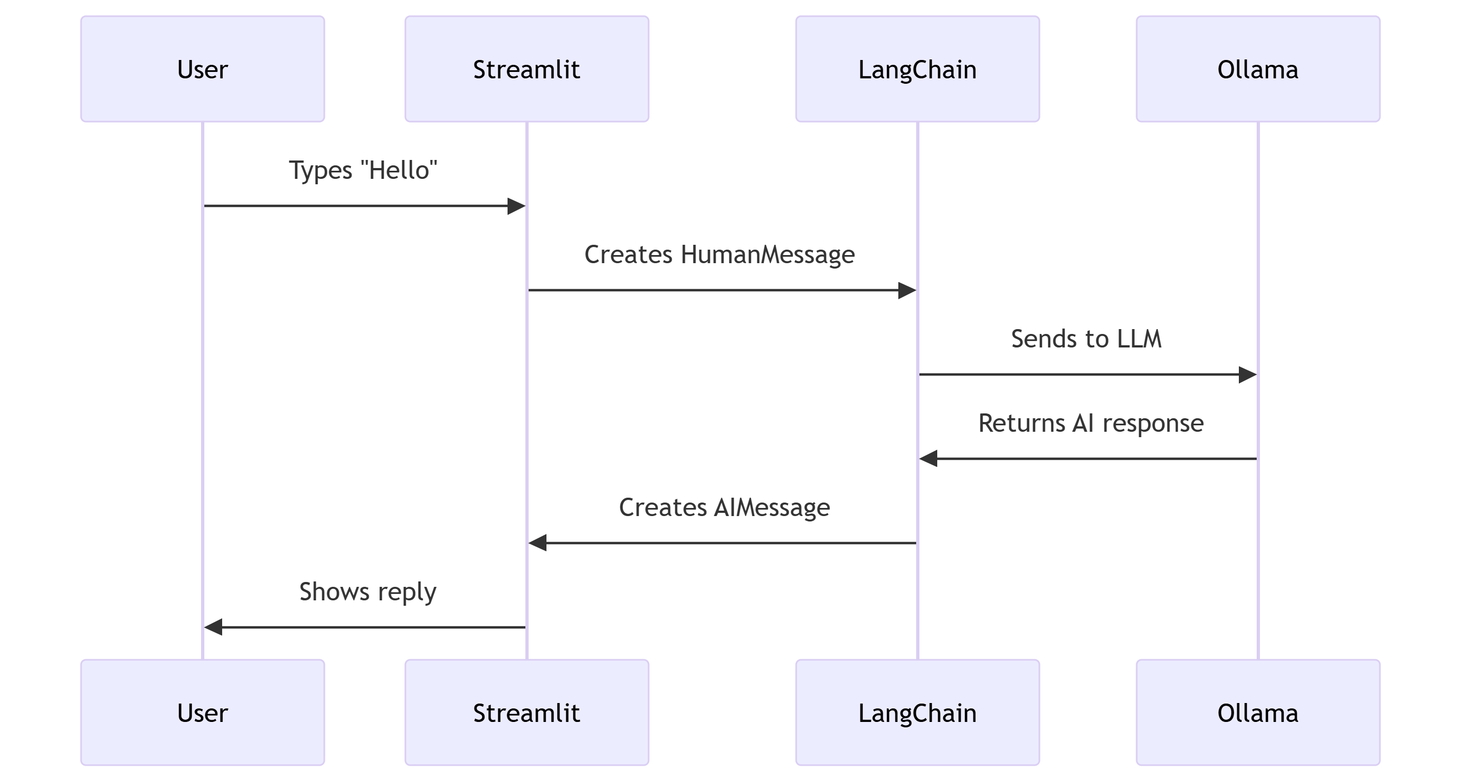
DIAGRAM:

